**Final Review Screen Shots**

**Disease:** Apoptosis

**Organism:** Mus Musculus

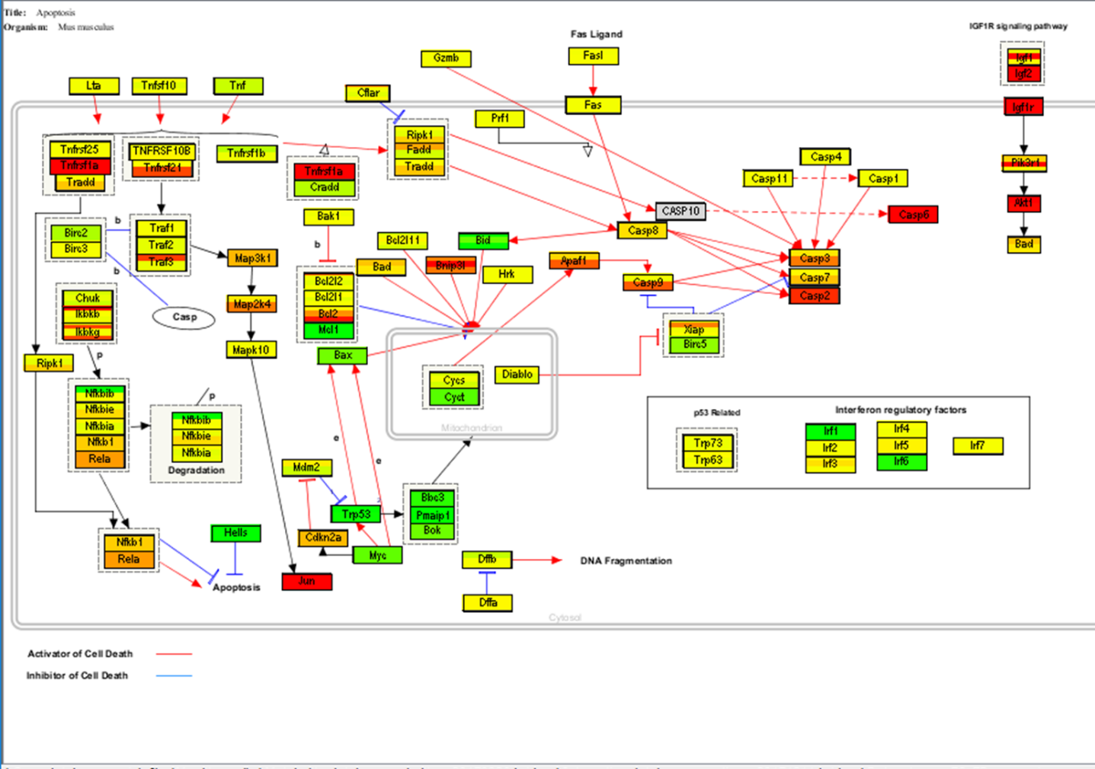

Fig. Pathway

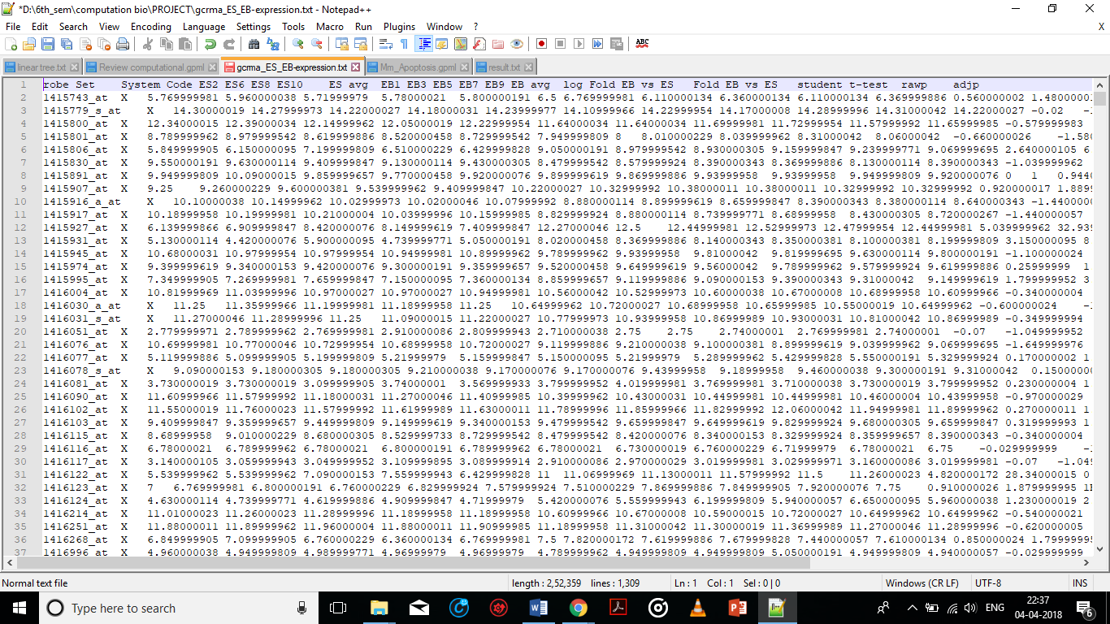

Fig. gcrma_ES_EB-expression.txt

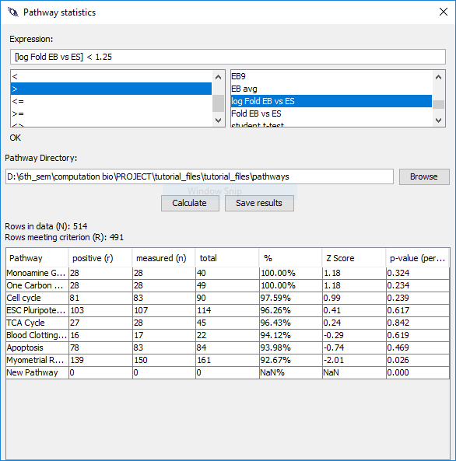

Fig. Statistics

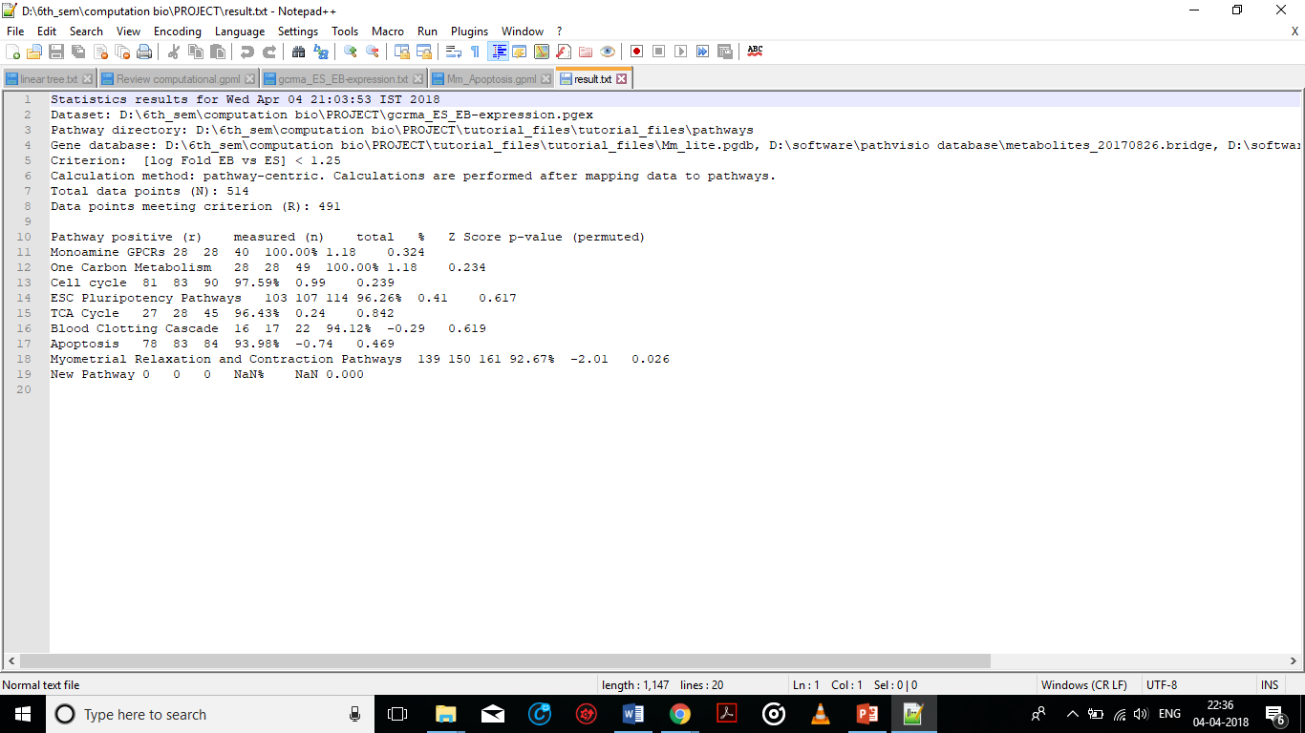

Fig. Result